The residential building located at Salt Lake City, is a G+4 structure and is under construction. During the construction, due to poor workmanship the durability of the structure was in doubt.
This was brought to the notice of the leading structural consultant in Kolkata Mr Sanjeev Parekh of SPA Consulants. Mr Parekh called for through investigation of structure and special technique like Non-destructive testing was carried out.

The following NDT tests were carried out,

- Rebound hammer test
- Ultrasonic Pulse velocity test

These tests revealed that the grade of the concrete achieved at site is of the order of M5 instead of M25, also UPV test confirmed the presence of voids in the column concrete.
The deficiency in grade of concrete had resulted in up to 80 % reduction in axial load carrying capacity of columns.

The consultant called Fosroc Chemicals (I) Pvt Ltd to study the reports of NDT and to suggest a suitable methodology of strengthening. Accordingly the Engineers from Fosroc visited the site and collected relevant data.

After the study of NDT report the different techniques of strengthening like micro concrete encasement and composite fiber wrapping were thought of.
The requirement of the client were,

- No more loading on the structure by using conventional techniques
- Less labor cumbersome
- Within least possible time the repair to be completed
- Economical treatment
- Do not wanted reduction in floor area etc.

To overcome all the above problems, densifying of columns by epoxy grouting followed by composite fiber wrapping with Carbon fiber was suggested.

Project CF 208, Salt Lake City Building

Industry Building Residential

Location Kolkata

Year of Completion 2006

Consultant Mr. Sanjiv J. Parekh,
M/S S.P.A. Consultants
53,Justic Chandra Madhab Road
Kolkata-20

Product Nitowrap EP (CF), Conbextra EP10, Lokfix S, Nitowrap 410, Nitoprime 30,Rendroc FC

Applicator M/S NuTech Engineering

197, Park Street, Kolkata-17

- The 17 columns were marked and thoroughly examined for undulations and soundness, holes were drilled at intervals and nozzles were fixed for grouting.
- Eopxy grout, Conbextra EP10 was injected through these nozzles to densify the porus concrete.
- Through surface preparation was carried out using wire brush, corners were grounded using grinder followed by blowing compressed air to remove all dust and deleterious matter.
- A layer of Rendroc FC was applied to mask the blowholes and imperfections on the surface of column.
- Nitowrap 30, a primer was then applied and allowed to dry for 12 hours.
- Nitowrap 410, a saturant was applied on the primer at a wet film thickness of 250 microns.
- Nitowrap EP (CF) carbon fiber wrapping system was then applied to columns , keeping the direction of fiber in the direction of stirrups and overlap of 100 mm was given at locations.`
- When the saturant is tacky, sand was sprayed/sprinkled to establish a mechanical key for plastering.

Typical Application Photographs

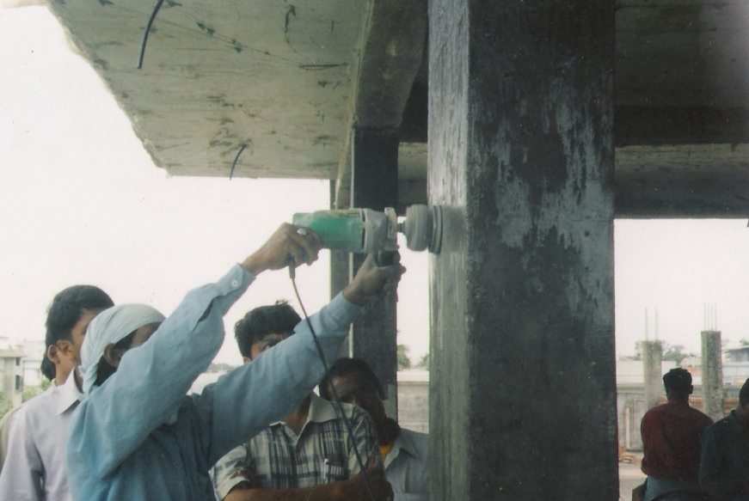

Surface preparation & cleansing

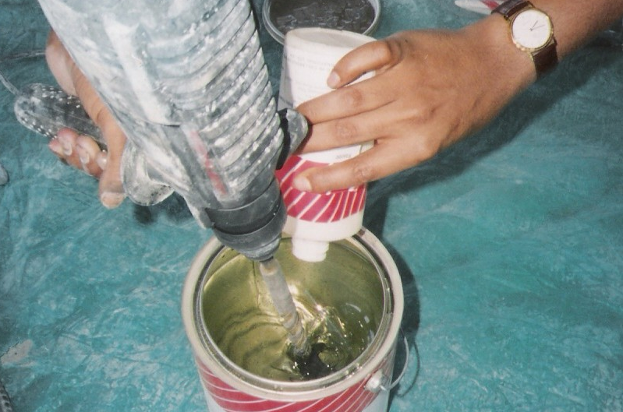

Mixing

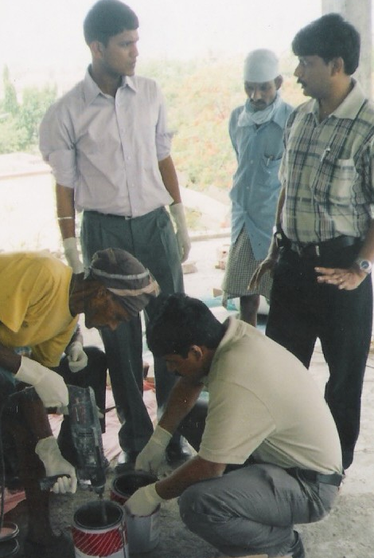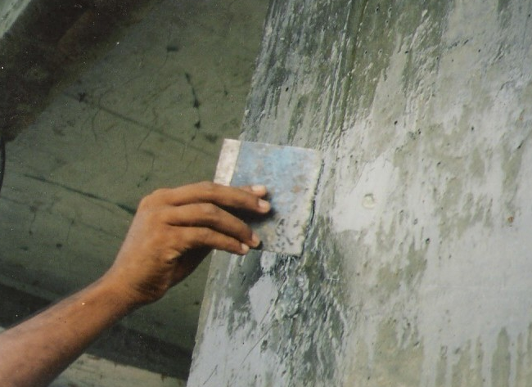

Mixing Surface Preparation

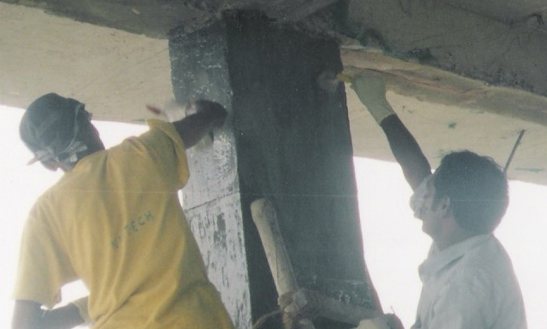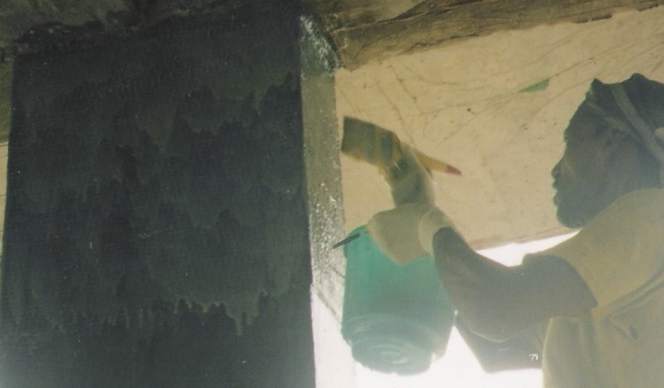

Application of Nitowrap 30 Application Of Nitowrap 410

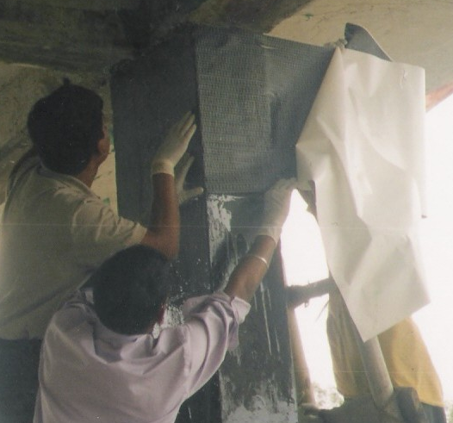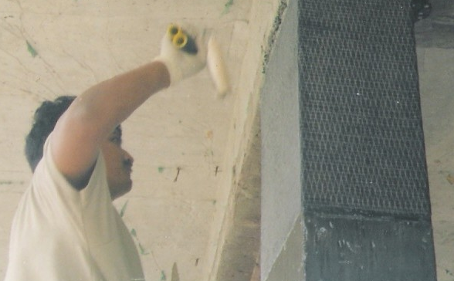

Application of Fiber Rolling

